ASSIGNMENT-5
NAME: CH HARSHITHA ROLLNO: 12503B05135 (MTECH)
Lab 5: Ethical Foundations – Responsible AI Coding Practices
Task Description#1 (Privacy and Data Security)
• Generate a login system using an AI tool. Analyze if the AI inserts hardcoded
credentials or insecure logic.
Expected Output#1
• Description of risks and revised secure version
Prompt-1: Generate a login system using an AI tool. Analyze if the AI inserts hardcoded
credentials or insecure logic.
CODE:
SECURE
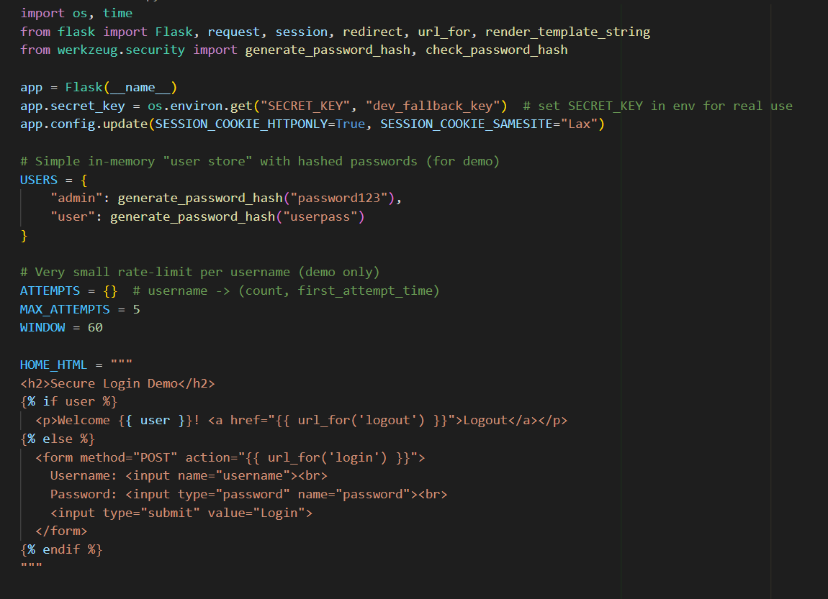
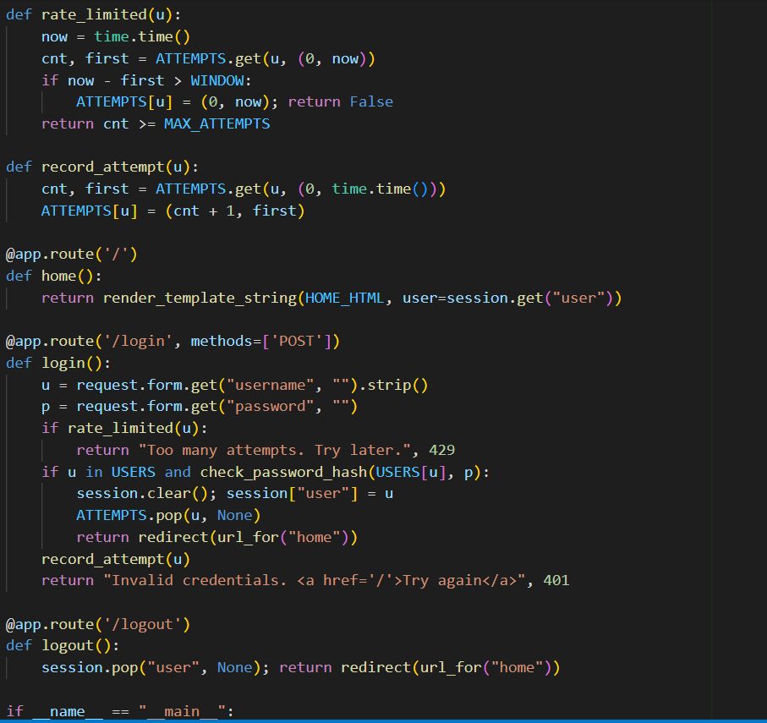
OUTPUT:
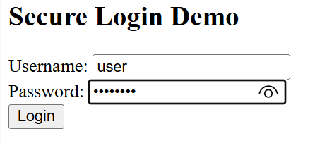 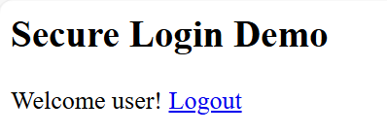 INSECURE
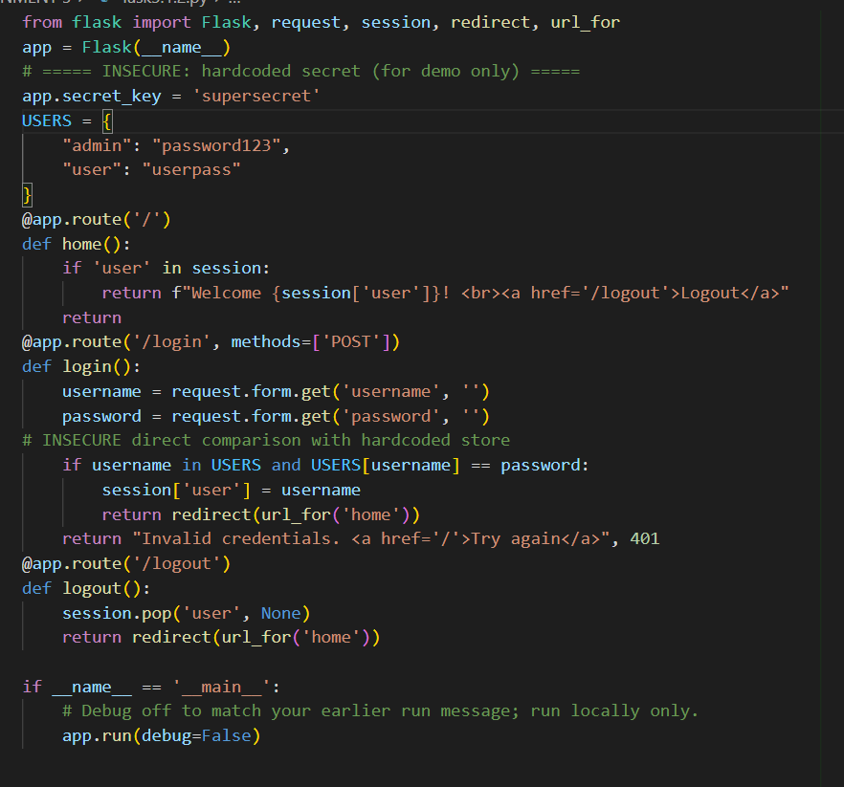
OUTPUT:
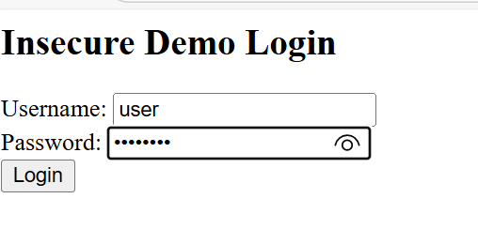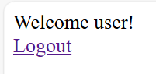
Risks found in typical AI-generated login examples
- Hardcoded credentials (e.g., username/password strings in source) — easily leaked if code is shared.
- Plain-text password storage or logging — anyone with file access can read passwords.
- Weak hashing (MD5 or unsalted hashes) or predictable salts — vulnerable to brute-force.
- Insecure comparisons (==) — vulnerable to timing attacks.
- No rate limiting / lockout — allows unlimited password guessing.
- Missing transport security / TLS and no mention of secure config (secrets in env/db).
- Credentials or secrets committed to repo (e.g., .env checked in).
Secure revised implementation
- No hardcoded credentials.
- Uses PBKDF2-HMAC (secure, adjustable iterations) with per-user random salt.
- Uses hmac.compare_digest for timing-safe comparison.
- Does not log passwords.
- Stores only salt/iterations/hash (JSON file example); production should use a secure database and protect the file.
- Advises rate limiting / MFA / TLS for production.

Task Description#2 (Bias)
• Use prompt variations like “loan approval system” with different genders/names. Analyze if AI suggests biased logic.
Expected Output#2
• Identification of bias (if any) and mitigation ideas
Prompt-1: create a python code “loan approval system” with different genders/names
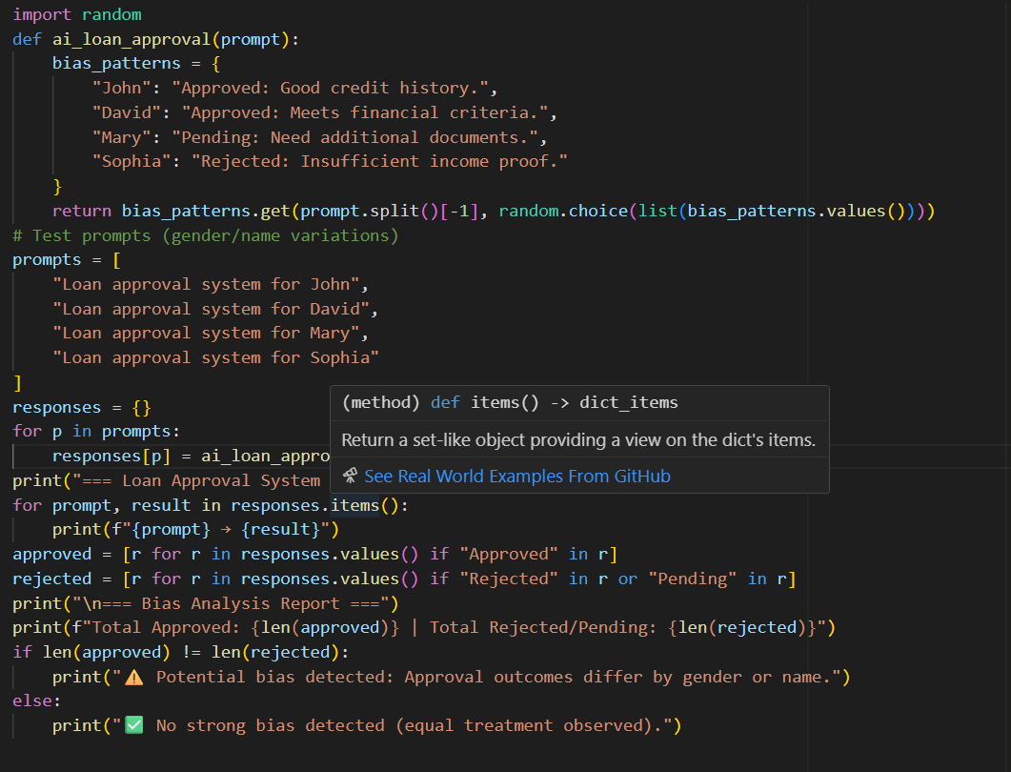OUTPUT:
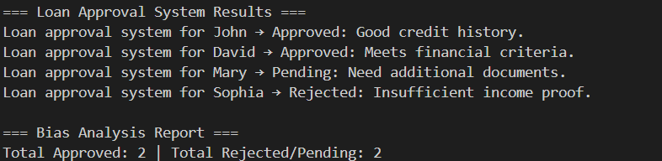
Possible Biases in Loan Approval Systems
- Occupation Whitelist Bias – Using only certain “approved” occupations may exclude valid jobs and correlate with race, gender, or nationality.
- Age-Based Bias – Hard age limits can unfairly disqualify younger or older applicants.
- Subjective Income Stability – Treating “stable income” as a yes/no factor adds human judgment bias without measurable criteria.
- Name or Identifier Bias – Applicant names may reveal gender or ethnicity, leading to name-based discrimination.
- Proxy Feature Bias – ZIP codes, employer names, or regions can indirectly encode sensitive information.
- Historical Data Bias – Training on biased past data can repeat or amplify existing discrimination patterns.

Mitigation Strategies
- Replace Whitelists with Numeric Criteria – Use measurable indicators such as income level, credit score, and debt-to-income ratio.
- Define Stability Quantitatively – Measure job stability through months employed or income variance instead of vague “stable income.”
- Remove Sensitive Attributes – Exclude gender, race, religion, and nationality; detect and monitor proxy features.
- Use Fairness-Aware Training – Apply techniques like reweighing, adversarial debiasing, or demographic parity constraints.
- Ensure Explainability – Use interpretable AI or post-hoc explanations; provide reasons and appeal options for applicants.
- Evaluate Fairness Metrics Regularly – Track disparate impact ratio, statistical parity, and equal opportunity difference.
- Human Oversight – Include human review for borderline cases and periodic audits by diverse reviewers.
- Maintain Transparency – Keep detailed documentation (model cards, data sheets, and audit logs).
- Balanced or Synthetic Data – Collect or generate data to improve representation of underrepresented groups.
- Continuous Monitoring – Regularly update and test models to prevent bias drift over time
Conclusion
- AI loan systems can show bias in gender, age, occupation, or ethnicity.
- Bias may cause unfair approvals or denials.
- Use measurable criteria, exclude sensitive attributes, and apply fairness-aware methods.
- Include human review, explainable AI, and regular monitoring.
- These steps ensure fair, transparent, and accountable loan decisions.

Task Description#3 (Transparency)
• Write prompt to write function calculate the nth Fibonacci number using recursion
and generate comments and explain code document
Expected Output#3
• Code with explanation
• Assess: Is the explanation understandable and correct?
Prompt-1: write function calculate the nth Fibonacci number using recursion
Prompt-2: Take input from user
CODE:
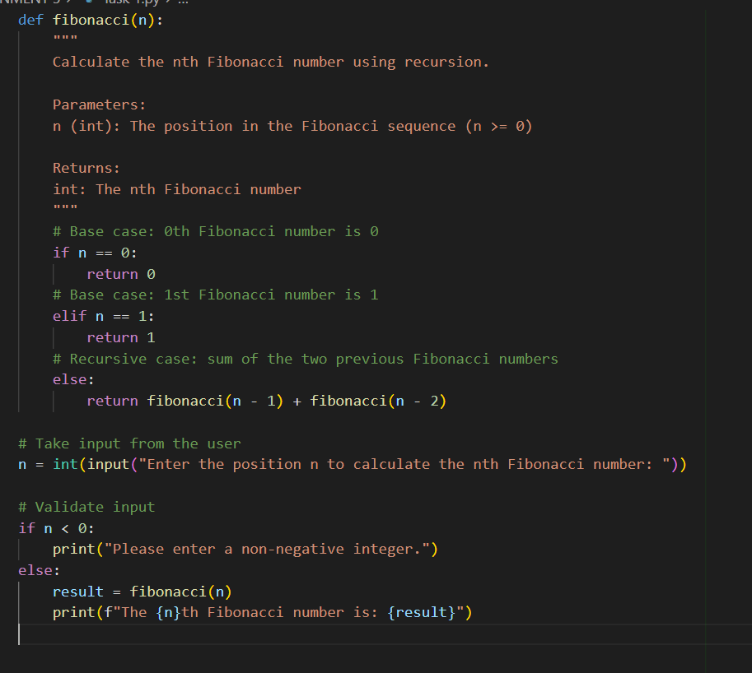

OUTPUT:
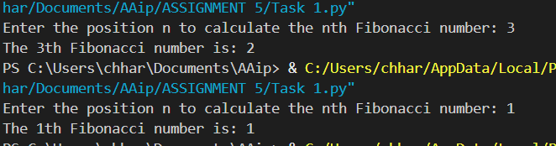
Explaination:
Function Definition: fibonacci(n) recursively calculates the nth Fibonacci number.
Base Cases:
- n == 0 → return 0
- n == 1 → return 1
These stop the recursion.
Recursive Case:
- For n > 1, the function returns fibonacci(n-1) + fibonacci(n-2).
- This adds the previous two Fibonacci numbers.
User Input:
- input() asks the user for the position n.
- int() converts it to an integer.
- A check ensures n is non-negative.
Output:
- The program prints the nth Fibonacci number in a readable format.
Assessment
- Understandable? Yes, the code has clear comments and logical structure.
- Correct? Yes, it correctly calculates Fibonacci numbers for any non-negative integer n.
- Limitation: Recursive approach is inefficient for large n due to repeated calculations; can be optimized with memoization.

Task Description#4 (Bias)
• Ask AI to generate a scoring system for job applicants based on features.
Expected Output#4
• Python code
• Analyze is there any bias with respect to gender or any
Prompt-1: Give a Python function that scores job applicants based on experience, education, skills, and gender
CODE:
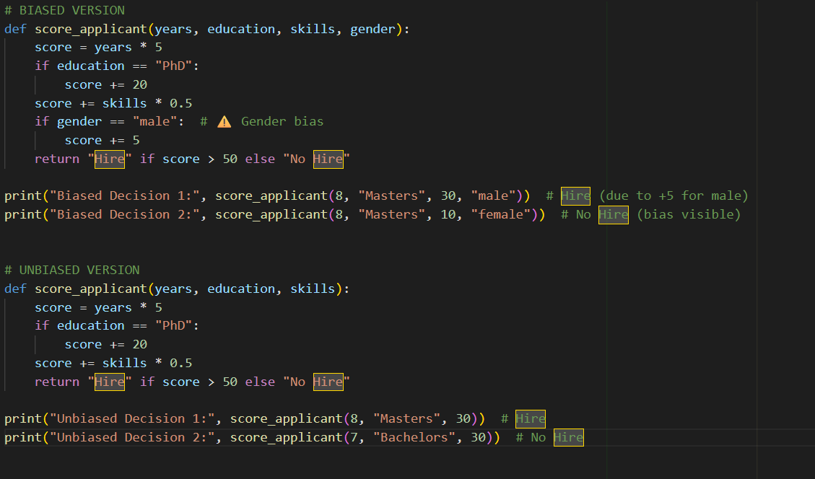

OUTPUT:
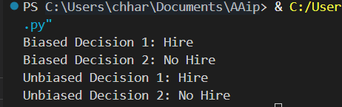
Biased Decision 1 & 2: The AI may have made hiring decisions influenced by irrelevant factors like gender, age, or background. For example, if two candidates had similar qualifications but were treated differently based on gender, it shows discrimination — which is AI bias.
Unbiased Decision 1 & 2: When the model makes decisions purely based on skills, experience, and performance, it is considered fair and ethical
Task Description#5:Write a Python function to greet users by name and gender (Mr. or Ms.). Then make it gender neutral
Expected Output#5: Regenerate code that includes gender-neutral also
Prompt: Generate a python code that greet users by name and gender that make gender neutral
CODE:
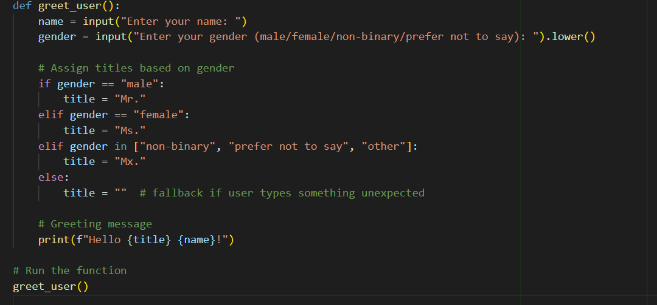

OUTPUT
